1. Load Image :

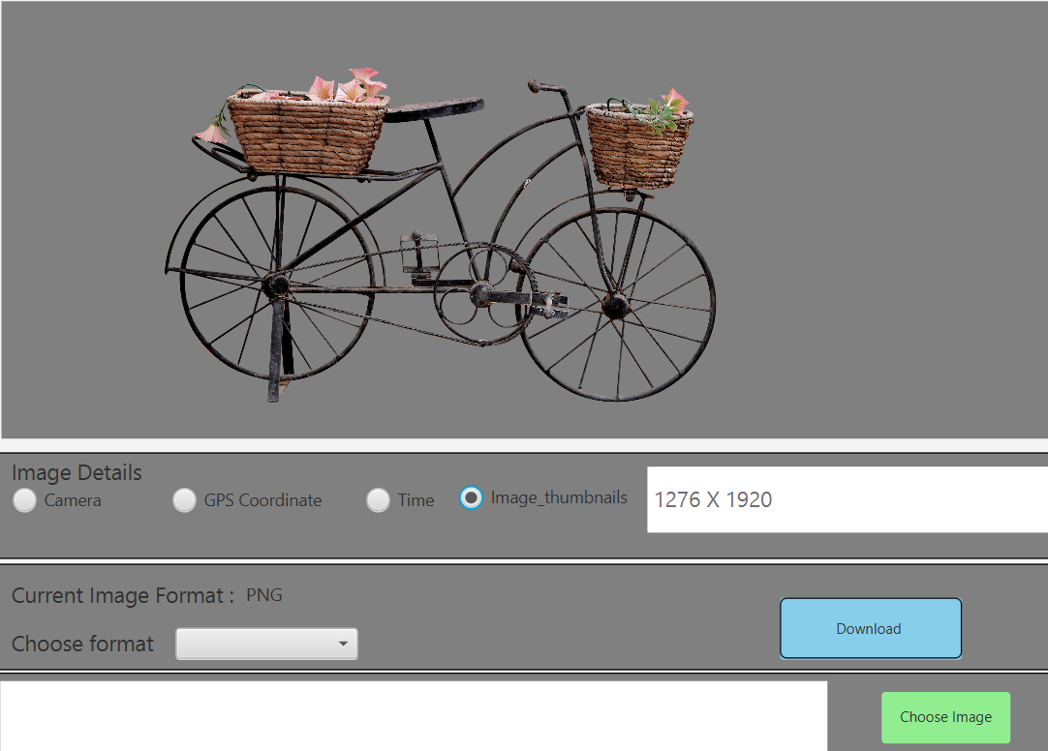

1. Show details:

Thumb details:



Camera:

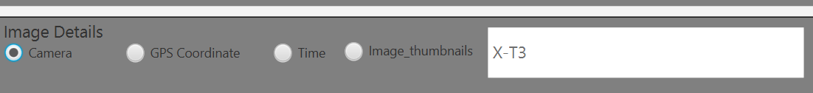

GPS:

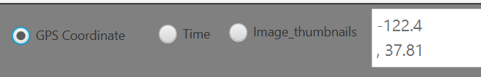

Time:



If: any of the details are not available for an image:



3 . Showing Current image format:

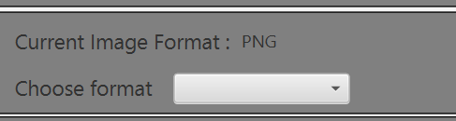

1. Choosing the format and downloading: here converting .png file to => .JPG

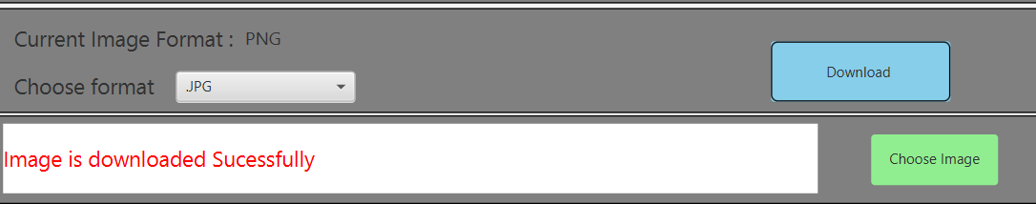

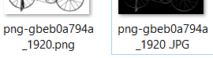

1. Gives following error message on choosing download button without loading the image.

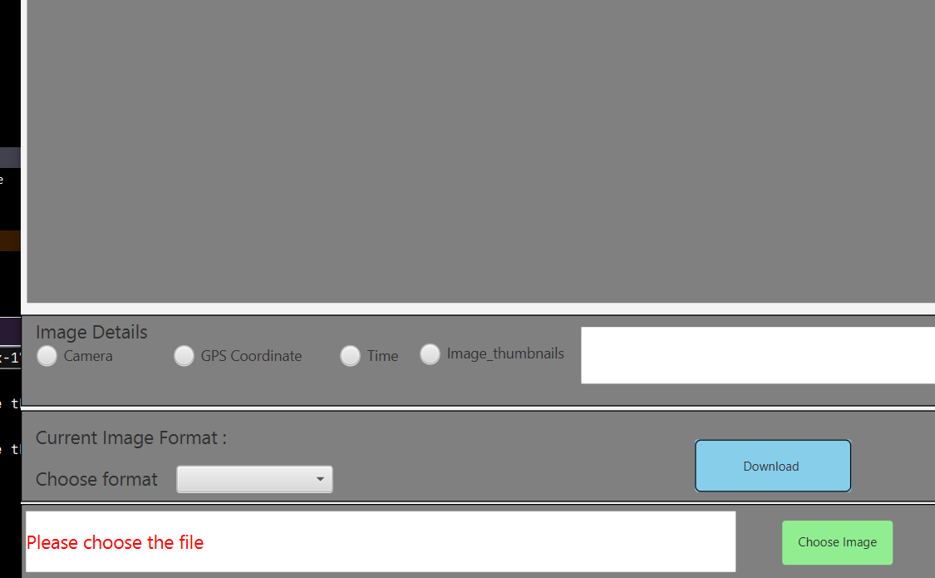

1. Shows following error, when selected any radio buttons without loading the image.

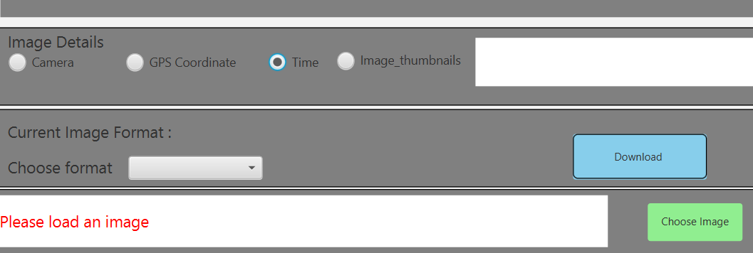

1. If we choose any file that is not an image format (GIF,JPG,TIFF,TIF,JPEG,PNG), we get following error

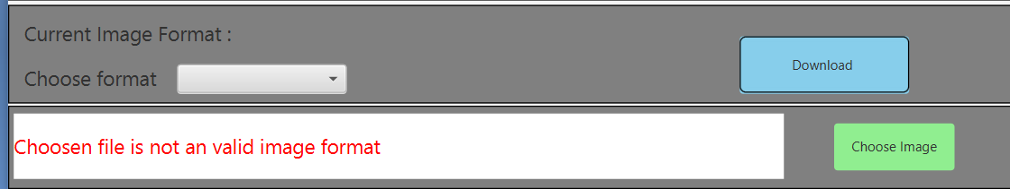

1. Downloading the image not choosing the format

